 Kandahar University

Faculty of Computer Science

Database Department

Fifth semester

Subject: Oracle/Software ENG

Teacher: Naveed Ahmad (Hematmal)

Project Name: Bank Management System

Year: 2022/1401

Semester: 3rd

***Group ladder:*** Ahmad Zubair “Afghanmal”

***Deputy leader:*** Abdul Hai

***Our Group members as under:***

|  |  |  |  |
| --- | --- | --- | --- |
| CS ID | Father Name | Name | No |
| CS07008 | Abdul Jabbar | Ahmad Zubair “Afghanmal” | 1 |
| CS07078 | Mohammad Surgol | Abdul Hai | 2 |
| CS07077 | Abdul Ghani | Abdul Jalil | 3 |
| CS07004 | Haji Bazar Gul | Ahmad | 4 |
| CS | Haji Gul Jan | rafiUllah | 5 |

1. We have six entities in our bank management system, they are the following:
2. Bank
3. Branch
4. Customer
5. Loan
6. Employee
7. Accounts
8. The attributes of each entity are:
9. Bank attributes (Name, Address, Bank Number)
10. Branch Attributes (BR Number, Br Name, Br Location)
11. Customer Attributes (Name, Father-Name, Martial-Status, Amount, Phone-number, SSN, Gender, Account Number)
12. Loan Attributes (ID, amount, Type)
13. Accounts Attributes (Number, Type, Balance)

The analyses of our projects:

* We have 6 entities in our project schema, every one of them will define bravely:

1. The BANK entity has these three attributes: Bank name, bank address and a unique bank id.
2. The BRANCH entity has these three attributes: Branch name, a unique branch number and branch location.
3. The EMPLOYEE entity has these six attributes: employee name (name is composed attribute like: first name, mid name and last name), employee gender, employee phone number, employee salary, employee birth date and a unique employee bank id.
4. The ACCONT entity has these three attributes: accounts types, accounts balance and a unique accounts number.
5. The LOAN has these three attributes: loan type, loan amount and a unique loan id.
6. The COUSTUMAR entity has these nine attributes: customer name (which is composite attribute: first name, mid name and last name), customer father name, customer marital status, customer gender, customer amount, customer a unique account number, customer phone number, customer SSN.

Attributes for our DBMS: 

ERD for our DBMS:

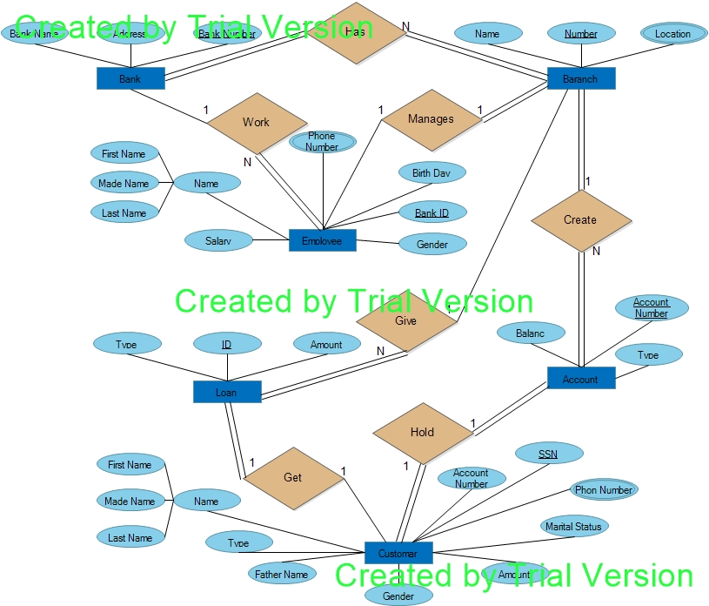

Mapping for our DBMS:

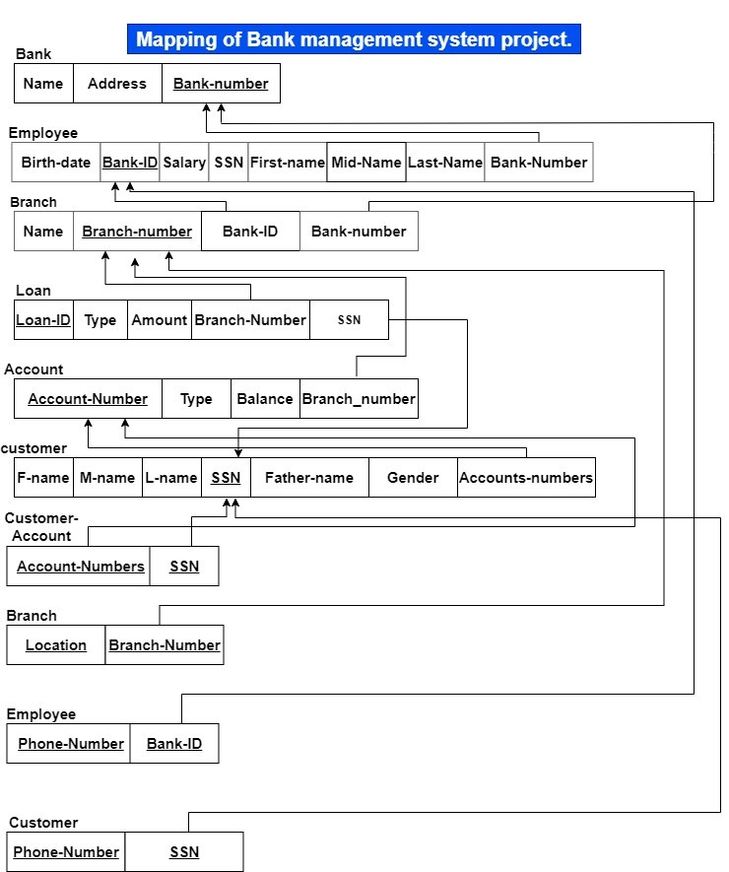

FINSHED.

THANK YOU!